Habit Tracking Application – User Manual

1. Introduction
The Habit Tracking Application is a Python-based console system designed to help users monitor daily and weekly habits. It supports predefined habits such as Water Intake, Exercise, Sleep, Reading, and Meditation.
This report presents the completed Habit Tracking Application developed across three phases: conception, implementation, and finalization. The system is designed to help users track daily habits, analyse performance trends, and maintain long-term consistency. The final version integrates a modular architecture, persistent storage via SQLite, and a rich set of analytics accessible through an 11-option command-line menu.

2. System Requirements
- Python 3.10 or higher
- SQLite (included automatically with Python)
- Terminal or command-line interface
- Project folder containing all modules and database file

3. Starting the Application
- Open your terminal.
- Navigate to the project directory:
Code
cd habit_tracker
- Run the application:
Code
python main.py

4. Main Menu Overview
When the program starts, you will see a menu similar to:
- View Habits
- Record Habit
- Longest Streak
- Current Streak
- Streak Statistics
- View Records
- Daily Report
- Weekly Report
- Monthly Report
- Habit Leaderboard
- Exit
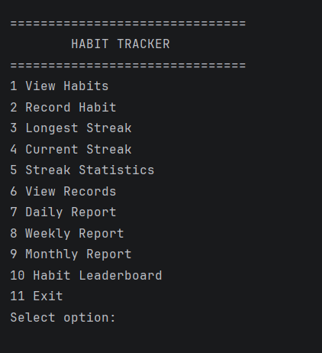
You can select an option by entering its number and pressing Enter.

Figure 1: Main menu of the Habit Tracking Application displaying all 11 available options

5. Menu Options in Detail

5.1 Option 1 – View Habits
This option displays all predefined habits stored in the system. For each habit, the following information is shown:
- ID
- Name
- Frequency (e.g., daily)
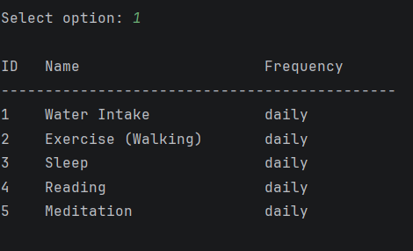
Use this screen to identify the habit ID you need when recording entries or viewing streaks.

Figure 2: Predefined habits with their IDs and daily frequency.

5.2 Option 2 – Record Habit
This option allows you to record a new entry for a selected habit.
Typical flow:
- Enter the habit ID (as shown in “View Habits”).
- If multiple units are available, select the desired unit (e.g., liters, gallons, hours, minutes).
- Enter the value (e.g., 2 liters, 30 minutes).
- The system validates the input and confirms that the entry has been recorded successfully.
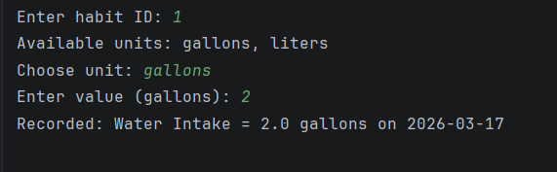
Entries are stored in the SQLite database with habit ID, value, unit, and date.

Figure 3: Recording a Water Intake entry with unit selection and confirmation.
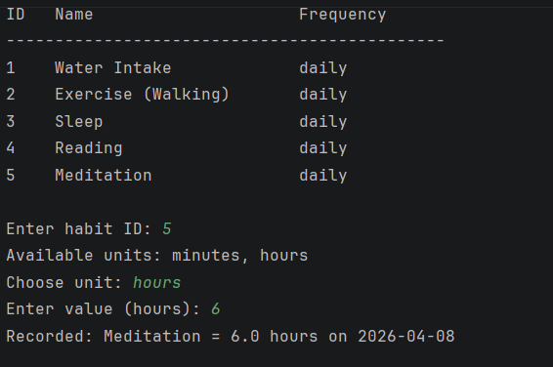

Figure 4: Successful recording of a Meditation habit entry.

5.3 Option 3 – Longest Streak
This option shows the longest streak for a specific habit.
Steps:
- Enter the habit ID.
- The system calculates and displays the maximum number of consecutive days the habit was completed without interruption.
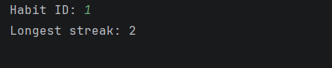
This helps you understand your best historical performance for that habit.

Figure 5: Longest streak result for Habit ID 1.

5.4 Option 4 – Current Streak
This option shows the current streak for a specific habit.
Steps:
- Enter the habit ID.
- The system calculates how many consecutive days you have maintained the habit up to today.
This is useful for tracking ongoing consistency.
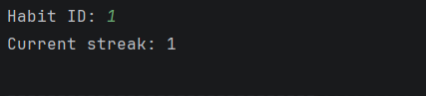
Figure 7: Current streak result for Habit ID 1.
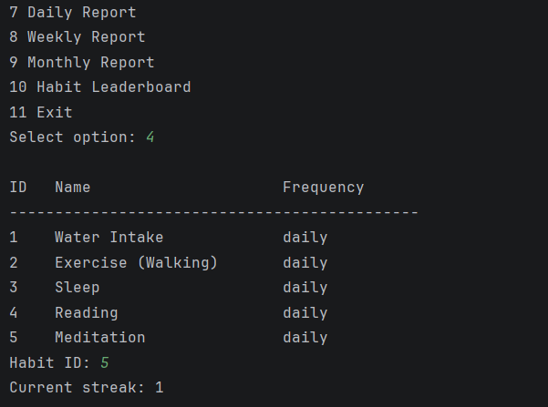
Figure 8: Current streak displayed through the main menu.

5.5 Option 5 – Streak Statistics
This option provides detailed streak statistics for a habit, such as:
- Maximum streak
- Minimum streak
- Average streak length
Steps:
- Enter the habit ID.
- The system analyses all recorded streaks and displays the aggregated statistics.
This gives a deeper view of long-term performance patterns.
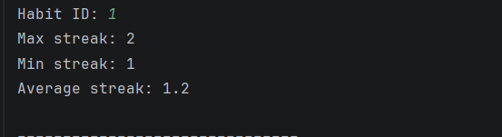
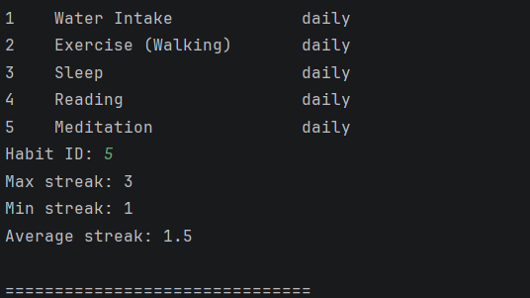
Figure 9: Detailed streak statistics for Habit ID 1.

Figure 10: Performance summary for a selected habit.

5.6 Option 6 – View Records
This option lists all recorded entries for all habits.
Each record typically includes:
- Habit name
- Value
- Unit
- Date
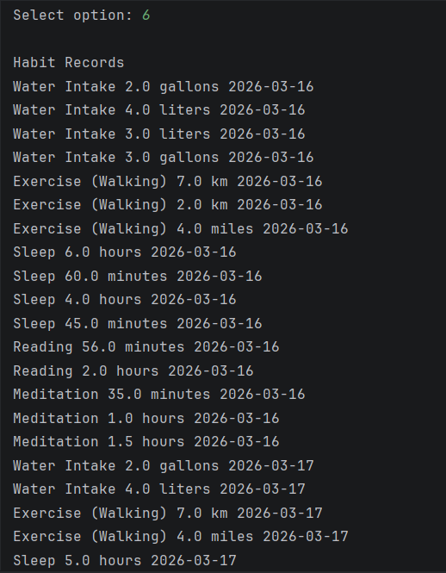
Use this view to inspect raw data and verify that entries have been stored correctly.

Figure 11: Complete list of recorded habit entries with values, units, and timestamps.

5.7 Option 7 – Daily Report
This option generates a daily report for the current day.
The report shows, for each habit:
- Whether it was completed today (e.g., “Completed” / “Not completed”)
This provides a quick overview of your performance for the current day.
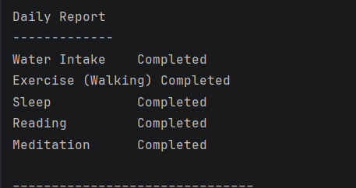

Figure 12: Daily report showing completion status for all habits.

5.8 Option 8 – Weekly Report
This option generates a weekly report summarizing the last 7 days.
For each habit, the report may show:
- Number of days completed out of 7
- A progress indicator or percentage
This helps you evaluate short-term consistency across the week.
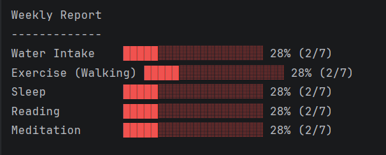
Figure 13: Weekly report summarizing habit completion across the last 7 days.

5.9 Option 9 – Monthly Report
This option generates a monthly report summarizing the last 30 days.
For each habit, the report may show:
- Number of days completed out of 30
- Completion percentage
- Visual progress representation (e.g., progress bars)
This supports long-term trend analysis.
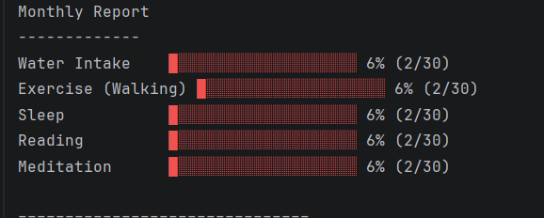

Figure 14: Monthly report summarizing habit performance over 30 days.

5.10 Option 10 – Habit Leaderboard
This option displays a leaderboard ranking habits by performance.
Typical information includes:
- Habit ranking
- Completion percentage or score per habit
The leaderboard highlights which habits are most consistently maintained.
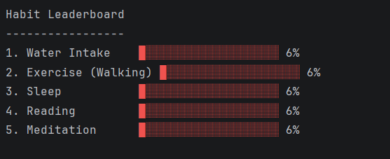
Figure 15: Habit leaderboard ranking habits by consistency

5.11 Option 11 – Exit
This option closes the application.
When you select 11, the program terminates safely and returns you to the terminal.

6. Data Storage
All habit entries are stored in a local SQLite database (e.g., data/habits.db). The database ensures:
- Persistent storage across sessions
- Efficient querying for analytics
- Reliable streak calculations

7. Troubleshooting
- Database not found → Ensure the data folder exists.
- Invalid input → Enter numeric values where required.
- Habit not updating → Check if the habit allows multiple entries per day.
- No habits shown: Ensure the database and predefined habit setup are correctly initialized.
- Invalid input errors: Use numeric values where required and valid habit IDs.
- No streaks or reports: Make sure you have recorded entries for the relevant period.

8. Conclusion.
The Habit Tracking Application provides a structured way to record habits, analyze performance, and maintain consistency over time. The 11-option menu offers fine-grained access to streak analytics, detailed records, and summary reports.

APPENDIX — TECHNICAL DETAILS
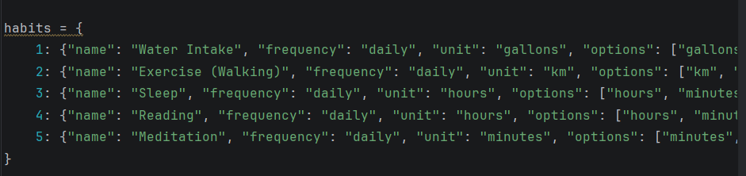

Figure 16: Python dictionary defining the five predefined habits.
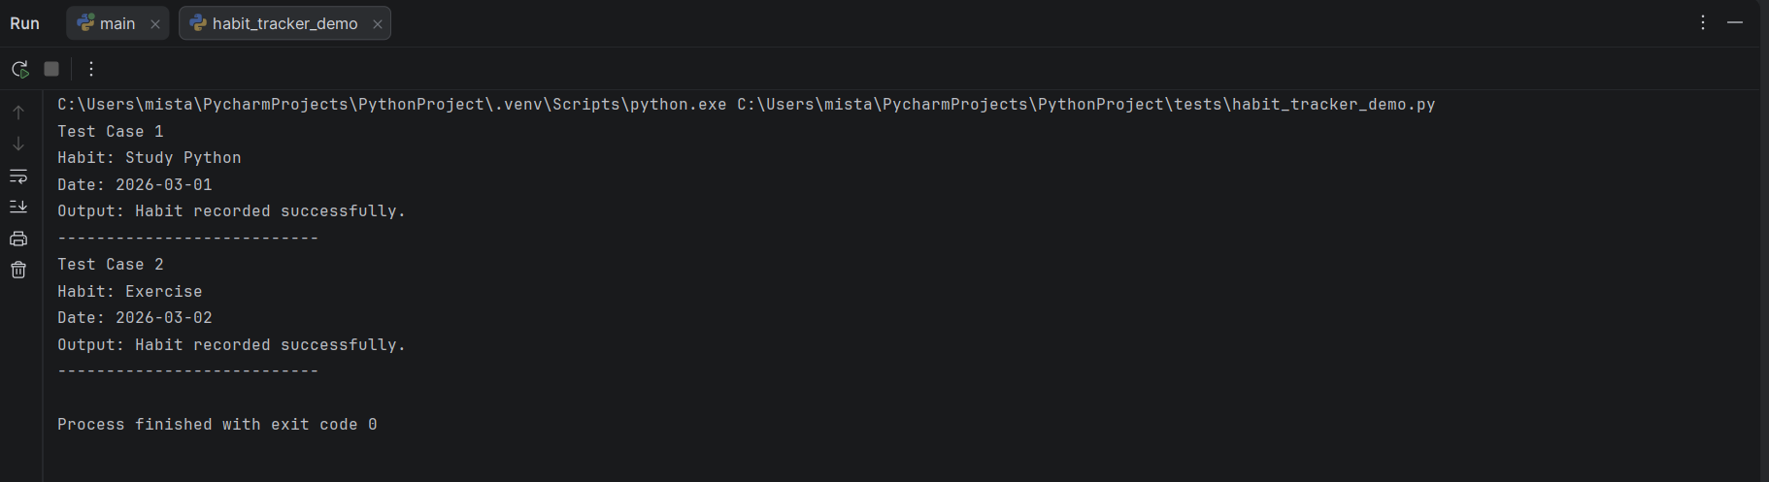

Figure 17: Automated test script confirming successful habit recording.

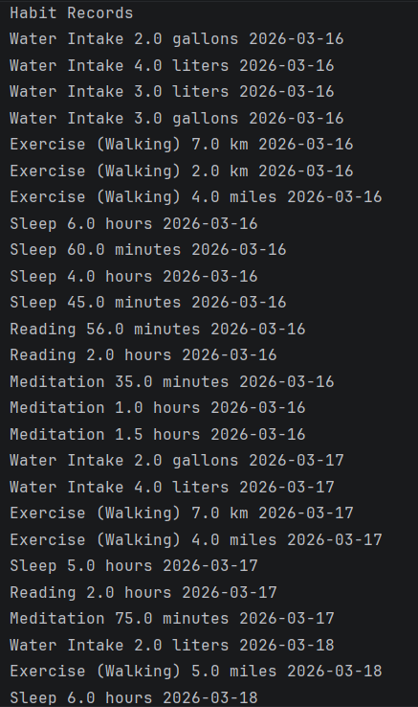
Figure 18: Generating dummy data for testing the habit tracker.

